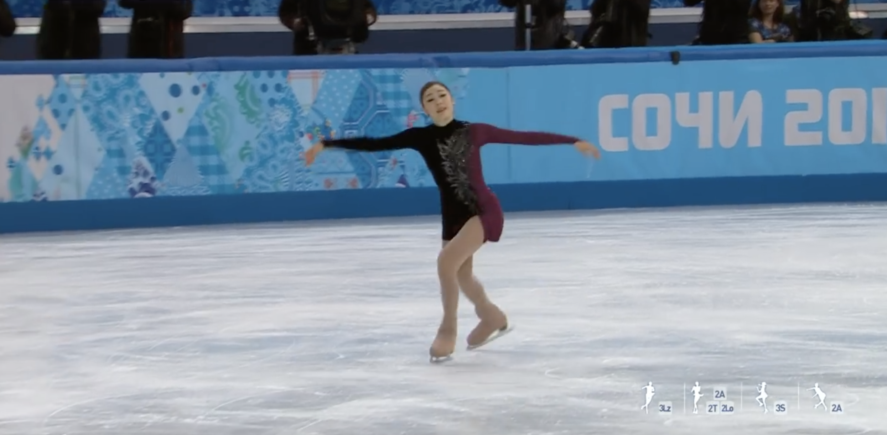
I am going to use rotoscoping to animate the last part of the stage of my favorite Vancouver Olympic gold medalist, figure skater.

